# **Time Series Analysis in Python**

This repository contains a series of analysis, transforms and forecasting models frequently used when dealing with time series. The aim of this repository is to use the Consumer Price Index dataset and understand the various aspects of the inherent nature of the series so that we are better informed and take meaningful inferences and build accurate forecasts.

# **Dataset**

The Dataset used is the Consumer Price Index (monthly, seasonally adjusted) during the calendar years 2010 to 2021 as provided by the Government of Canada. The data from the food column is pulled and pre-processed to ensure easier data handling and to save time. In this case, the series is already stationary with some next to no seasonalities which change every year.

Statistics Canada. [Table 18-10-0006-01 Consumer Price Index, monthly, seasonally adjusted](https://www150.statcan.gc.ca/t1/tbl1/en/tv.action?pid=1810000601)

DOI:<https://doi.org/10.25318/1810000601-eng>

# **Analysis and transforms**

* Time series decomposition
  + Level
  + Trend
  + Seasonality
  + Noise
  + Lag
* Stationarity
  + AC and PAC plots
  + Moving Averages
  + Dickey-Fuller test
* Making our time series stationary
  + Smoothing
  + Moving averages

# **Models tested**

ARIMA, short for ‘Auto-Regressive Integrated Moving Averages’ is actually a class of models that ‘explains’ a given time series based on its own past values, that is, its own lags and the lagged forecast errors, so that equation can be used to forecast future values.

A pure **Auto-Regressive (AR only) model** is one where Yt depends only on its own lags. That is, Yt is a function of the ‘lags of Yt’.

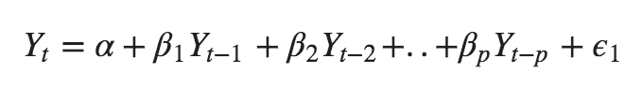

Likewise a pure **Moving Average (MA only) model** is one where Yt depends only on the lagged forecast errors.

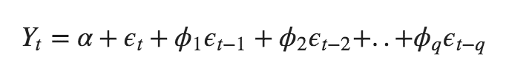

where the error terms are the errors of the autoregressive models of the respective lags. The errors Et and E(t-1) are the errors from the following equations :

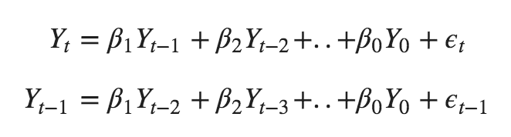

An ARIMA model is one where the time series was differenced at least once to make it stationary and you combine the AR and the MA terms. So the equation becomes:



**Getting Started**

### **Dependencies**

* Python IDE or Python notebook (Jupyter or Google Colab)
* Libraries needed: Pandas, NumPy, MatPlotLib, Statsmodels, Pmdarima, SciPy, Sci-kit Learn

### **Installing**

* Clone the repository  
  git clone https://github.com/microsoft/forecasting

cd forecasting/

* Run setup scripts to create conda environment. Please execute one of the following commands from the root of the Forecasting repo based on your operating system.
  + Linux

./tools/environment_setup.sh

* + Windows

tools\environment_setup.bat

(Note that for Windows you need to run the batch script from Anaconda Prompt. The script creates a conda environment forecasting_env and installs the forecasting utility library fclib.)

* Start the Jupyter notebook server  
  jupyter notebook
* Run the [LightGBM single-round](https://github.com/microsoft/forecasting/blob/master/examples/grocery_sales/python/00_quick_start/lightgbm_single_round.ipynb) notebook under the 00_quick_start folder. Make sure that the selected Jupyter kernel is forecasting_env.
* If you have any issues with the above setup, or want to find more detailed instructions on how to set up your environment and run examples provided in the repository, on local or a remote machine, please navigate to the [Setup Guide](https://github.com/microsoft/forecasting/blob/master/docs/SETUP.md).

## **Authors**

Vibhuti Gandhi

Discord: ginko#5274

LinkedIn: <https://www.linkedin.com/in/vibhuti-gandhi-8679ba1bb/>

### 